

SUPPLY CHAIN MITIGATION STRATEGY
Revised 2026
Task # 9

Table of Contents
Introduction 3
Purpose 3
BBHCC’s Role in Supply Chain Operations 3
BBHCC Supply Chain Assessment/ Resource Needs 3
Healthcare Supply Chain Operations 4
Healthcare Supply Chain Under Normal Operations 5
Supply Chain Hazards, Threats, and Vulnerabilities 6
Steady State Supply Chain Challenges (Impact on Communities) 6
Pre-Event, Response and Recovery Considerations 7
Manufacturer Considerations 7
BBHCC and Manufacturing 8
Distributor “Wholesaler” Considerations 8
BBHCC and Distributors 9
Provider Considerations 10
BBHCC and Providers 10
Patient Considerations 10
BBHCC and Patients 10
The BBHCC does not directly connect with patients but can help communicate risks and provide situation awareness to member facilities, who can in turn provide that information to their patients, etc. 10
BBHCC Considerations-Current Access and Infrastructure/Mitigation Strategies 10

Introduction
The healthcare supply chain is complex. It supports patient care daily by producing and delivering medications as well as products ranging from gloves and gowns to diagnostics, to pharmaceuticals and biomedical equipment, to surgical supplies and other devices or services that support the healthcare sector. During disasters or other catastrophic events, the healthcare supply chain can experience distinct strains depending on the nature of the event and the impact on surrounding infrastructure.

Purpose
This document is intended to provide an overview of the emergency planning and response considerations of healthcare supply chain owners, operators, and end users, as well as insight for the Big Bend Healthcare Coalition (BBHCC) to work with healthcare supply chain partners on preparedness, response, and recovery. It is not intended to be a comprehensive listing but aims to capture key changes during serious or catastrophic events, compared to normal supply chain operations, as well as planning and response contingencies.

BBHCC’s Role in Supply Chain Operations
The BBHCC plays a key role in linking public sector response agencies, including emergency management agencies and public health departments, and private healthcare facilities that serve as points of service. The BBHCC is a key stakeholder and though not a direct component of the supply chain, the BBHCC can act as a coordination point between vendors/suppliers and healthcare facilities to address supply disruptions. During blue skies, the BBHCC assists members with supply chain readiness and response planning through training, exercises and information sharing.
By serving in coordination and information sharing capacity the BBHCC can prepare members with supply chain readiness through the following ways:
- Encouraging best practices in communicating and engaging with supply chain components.
- Standardizing and providing guidance on activities that impact supply chain operations during emergencies.
- Provide opportunities for supply chain components and coalition members to train and exercise together.
The BBHCC serves as a conduit between its member facilities and emergency response organizations across its service area, with the goal of linking disaster preparedness and response plans to provide care and protect public health in the Region. The BBHCC acts as an information sharing entity for distributors and providers and can share product and delivery information and strategies. Additionally, the BBHCC has the capability to assist with resource requests and monitor the operational status and needs of healthcare facilities within the service area.

BBHCC Supply Chain Assessment/ Resource Needs
The updated supply chain integrity assessment identifies the region’s most critical resource needs, including fuel, medical gases, biomedical equipment support, transportation, and disposable medical supplies, all of which were repeatedly cited by BBHCC members as areas requiring sustained availability during emergencies. Assessment findings also highlight vulnerabilities such as limited vendor redundancy, dependence on just-in-time delivery models, and absence of formal agreements for essential resources. Current access and infrastructure limitations include variable distributor coverage across rural counties, uneven presence of local or regional supply chain managers, and inconsistent storage capacity for increased par levels. These gaps can significantly impact communities, particularly facilities serving medically fragile populations that rely on uninterrupted supply delivery. To enhance resilience, the assessment outlines mitigation strategies such as establishing alternate supplier agreements, increasing par levels for critical items, strengthening relationships with distributors through ESF-8 coordination, and standardizing resource request and information-sharing processes across the coalition.

Healthcare Supply Chain Operations
The healthcare supply chain involves the flow of numerous product types from manufacturer to patient and requires the participation of various stakeholders who work in concert to achieve the goal of meeting patient care needs.
Healthcare supply chain stakeholders include:
- Manufacturers
- Distributors
- Providers
- Patients
- Healthcare Coalitions
- Federal Programs¹
Descriptions of each stakeholder, their roles in the supply chain, and a few key vulnerabilities to plan for are included on the next few pages.
Under normal conditions, the complex processes that make up the supply chain are nearly invisible due to steady-state production and delivery of healthcare products. Healthcare supply chain stakeholders adhere to their daily roles and standard operating procedures.
The following infographic displays the normal operations and activities of healthcare supply chain stakeholders and key vulnerabilities for each stakeholder.

Healthcare Supply Chain Under Normal Operations
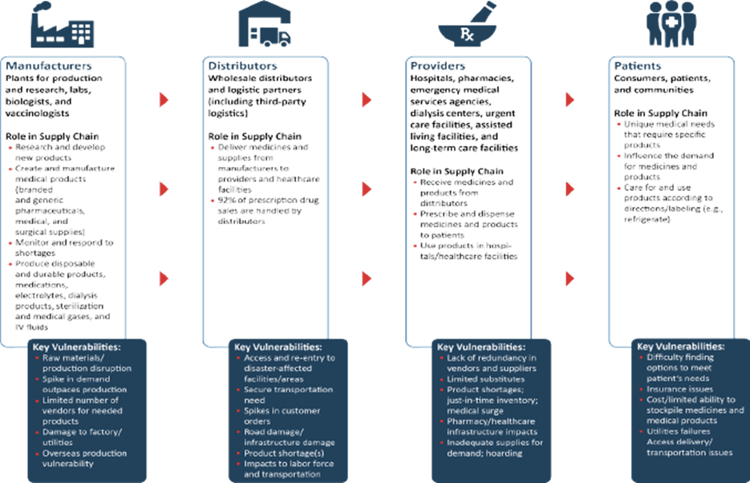

1 Although the healthcare supply chain is largely owned and operated by the private sector, several federal offices and agencies have a role in supporting the continuity of supply chain operations during emergencies and events that could impact healthcare operations and have established partnerships with key components of the supply chain in order to accomplish this. Appendix C outlines some of the key federal partners roles “at-a-glance” that are consistent with the purpose of this particular document.

Supply Chain Hazards, Threats, and Vulnerabilities
The healthcare supply chain is dependent on many variables including raw material availability, machinery and parts, workforce, standards compliance, delivery methods, contracts and regulatory requirements, and underlying critical infrastructure systems such as power, telecommunications systems, and transportation (including vehicle and roadway, airport, railroad, and port components). When one element is compromised there can be cascading effects up and down the supply chain.
Disruptions to these systems can be caused by various hazards, underlying vulnerabilities, and threats that can directly impact every level of the supply chain. Examples include the following:
- Natural Disasters – Natural disasters have the potential to disrupt the healthcare supply chain in all parts of the BBHCC Region. Common hazards include hurricanes, tornadoes, flooding, and wildfires. All phases and components of the chain may be affected after events regardless of notice and may require assistance with response and recovery efforts.
- Human-Caused Disasters – These hazards also vary and can include cyber-attacks, acts of terrorism, and unintentional catastrophes like an oil spill, damage or impacts to goods during delivery accidents, or even unforeseen equipment breakdown.

- Public Health Threats – Biological threats can impact the healthcare supply chain by creating both dramatically increased and sustained demand for products, especially medical supplies. These events include disease outbreaks (of both commonly occurring and emerging diseases) and biological attacks.
The top hazards facing the BBHCC Region as identified by the 2025-2026 Hazard Vulnerability Assessment are listed as follows:

  - Tropical Cyclones
  - External flooding
  - Critical Infrastructure failure
  - Cyberattacks
  - Extreme Heat
  - Severe Weather
  - Seasonal influenza

Supply chain implications for public health-centric events differ from those of a natural hazard in that public sector partners – via public health officials (state, local, and federal, including the Strategic National Stockpile [SNS]) – can play a significant role in supply chain operations through activation of programs, language included in emergency declarations and public messaging, and more. Vendors for commonly needed products during these events, including vaccines and personal protective equipment (PPE), are often limited. Depending on the nature of the event, demand for these products can far exceed production capacity.

Steady State Supply Chain Challenges (Impact on Communities)
To meet patient care demands, all stakeholders should focus on mitigating the supply chain hazards, threats, and vulnerabilities unique to their area while identifying key actions that will enhance resilience during incidents. Some impacts can be greatly reduced through integrated mitigation and planning. Working with providers in the community and distributors to forecast ordering for different scenarios, including emergencies, can help set use and delivery expectations and plans and highlight areas where back up options are required.
Usual system vulnerabilities (upstream and downstream) may include:
- Industrial and personnel – Work stoppages, fluctuating transportation costs or fuel supply issues, geopolitical events, sabotage, market forces, and technological failures may have negative effects impacts on components of the supply chain, especially those companies responsible for production and manufacturing.

- Operational – These can include production or supply problems such as lack of raw materials, lack of machine parts, regulatory actions (including product recalls), compressed manufacturing timeframes, product liability challenges, just-in-time ordering processes, disparate data systems, product cycles (obsolescence), and data silos between suppliers and providers.
- Just-in-time or low unit of measure programs – Healthcare providers often rely on these programs from their distributors. These programs keep costs down for providers and allow them to reduce labor costs, time, and space required to stock and rotate medical products. While these programs are efficient, they can also lead to fragile supply-demand relationships, especially during emergencies.
- Just-in-time (JIT) inventory delivery means distributors are servicing provider customers almost daily in order to keep minimal stock (or ”par” levels) at the facility.
- In low-unit-of-measure (LUM) programs, distributors are the central source of product for facilities and will deliver to the specific departments on demand. In these programs, distributors “break down” product to the “each.” (The “each” is the unit that is used on the patient. For example, distributors may take a box of 100 individually packaged items, break it down, and deliver 5.)
- Hospitals relying on JIT and LUM strategies can be vulnerable to both increased demand for supplies due to patient surges of patients and/or delayed delivery as a result of the effect of the disaster on distributors.
- Consumer or provider brand (or product) preference for usual medications, equipment, or consumer distrust of novel medications/vaccines.

Pre-Event, Response and Recovery Considerations
The following sections provide pre-event, response, and recovery considerations for various components of the healthcare supply chain. High-level considerations for the BBHCC are captured at the end of each section.

Manufacturer Considerations

Manufacturers create products – including pharmaceuticals, medical, and surgical supplies – using raw materials on-site in manufacturing plants and labs. As a part of the manufacturing process, these companies identify and develop needed products, determine quantities necessary to meet demand, acquire raw materials, conduct safety trials and obtain regulatory approvals as required, and then make and package products for distribution. Manufacturing is a diverse and complex discipline, and the field is made up of countless different stakeholders, including brand and generic pharmaceutical manufacturers, medical supply and device manufacturers, and scores of others. International sources of raw materials and manufacturing sites are common. The following considerations and mitigation and response strategies capture high-level themes common across the different types of manufacturers.

BBHCC and Manufacturing
Manufacturing occurs “upstream” in the supply chain. Given the BBHCC’s role in preparedness, response, and recovery coordination, which occurs “downstream” in the supply chain, the BBHCC does not engage directly with manufacturers. However, the BBHCC can keep current and informed on significant impacts to manufacturing capabilities, such as drug or PPE shortages. The BBHCC can share information via situation reports / newsletters that include strategies for addressing shortages between providers, as well as coordinate information exchange between distributors and providers.

Distributor “Wholesaler” Considerations
Distributors and logistics partners, including third-party logistics providers, acquire medical supplies from manufacturers and deliver them to providers and healthcare facilities. As part of this complex process, they may repackage, re-label, and ensure special handling for products, such as cold chain products requiring climate-controlled environments. A pharmaceutical distributor is more often referred to as “wholesaler,” whereas in the medical product supply chain, the term “distributor” is more often used. For purposes of this document, the term “distributor” is used throughout for consistency and clarity.
Strategic National Stockpile (SNS)
The SNS relies on partnerships with commercial distributors as these companies are already integrated into the market and can effectively move assets from the SNS to medical countermeasures (MCM) dispensing sites with established modes of transport, transportation routes, and accompanying security.
It is important to note that the primary pharmaceutical distributor for a healthcare facility will likely be different than the primary medical product distributor for the facility. Additionally, many distributors have a primary healthcare provider market, which means the primary distributor for the local hospital may not be the same as the one providing the same supplies for the nearby nursing home.
Providers have primary distributors for medical products and pharmaceuticals. However, they often have secondary distributors and specialty distributors that may focus on specific surgical procedures or equipment. It is important to understand those specialty
Allocation
When there is a product shortage, distributors may institute allocation practices. Allocation is a contractual obligation between the supplier and distributor that ensures customers get some amount of product based on a percentage of their historical purchasing. It does not take into account surge needs during a public health event which may exacerbate existing product shortages. Distributors commonly place regular customers on allocation during shortages and decline orders from new customers during that time.
products that are only available from a single source.

The pharmaceutical supply chain has three large national/multinational distribution companies that control 90% of the market. The companies, known as the “Big 3,” are McKesson, AmerisourceBergen, and Cardinal Health². There are also several regional companies that may be significant
The medical product supply chain is more varied with large national companies and regional companies for healthcare facility types or service lines (e.g., homecare). These distributors often have over 5,000 types of products on hand and depending on the product have approximately 20 to 30 days of inventory that reflects normal customer usage/consumption patterns³. Most urban healthcare centers are within 50 miles of a distribution center and most distributors can deliver within 24 hours of an order.
Third-party Logistics Providers (3PLs)
3PLs range from FedEx and other large postal service providers to smaller, regionally- or locally based companies. 3PLs frequently use unlabeled or unmarked trucks for deliveries. 3PLs play a critical role in “last mile” delivery.

Pharmaceutical and medical product supply chains may utilize the services of third-party logistic providers (3PLs) such as FedEx, UPS, and others depending on their business and service model. 3PLs can minimize costs and allow for local distribution through local companies familiar with the community. 3PLs can also enable more frequent deliveries from regional or local distribution centers (some facilities receive up to 4 deliveries per day.)

BBHCC and Distributors
The BBHCC should ensure partnerships are established with distributors as oftentimes the plans and activities of each impact one another. The BBHCC can assist with integrating distributors into ESF-8 and meeting face-to-face on a regular basis through coalition meetings, training and exercises, and the like will highlight the importance of these relationships and also identify key contacts that can be called upon during a response. Distributors should have a clear understanding of the role the local coalition plays during a disaster and how the coalition and distributor interface with the formal emergency management response structure in the jurisdiction so that information and resource requests can be managed according to local policy (including how to connect with local and state emergency management).

- Healthcare Distribution Alliance (2018). 89th Edition HDA Factbook: The Facts, Figures, and Trends in Healthcare. Retrieved from: https://www.hda.org/resources/
- Health Industry Distributors Association (2018). Health Systems Rely on Distribution. Retrieved from: https://www.hida.org/distribution/resources/infographics/Health-Systems-Rely-On-Distribution.aspx

Provider Considerations
Providers are a large and diverse group of facilities and professionals licensed to supply healthcare services and expertise, to include disbursing and dispensing medicines and products to patients. Key activities they undertake within the supply chain include submitting orders to distributors and providing data and information on healthcare services and needs that help identify shortages and potential distribution challenges. The considerations and mitigation and response strategies differ among provider groups considerably.

BBHCC and Providers
As both key members and stakeholders of the BBHCC, providers drive coalition activities. The BBHCC plays an important role in developing and disseminating information between their stakeholders (including emergency management) and with distributors, monitoring impact, and coordinating response activities during emergencies as per local ESF-8 plans. Providers look to the BBHCC for information sharing and standardization of activities, including those related to the supply chain such as substitution and conservation guidance. The BBHCC can also play a role in resource requests by serving as the conduit between local provided and their EM offices as needed. Additionally, the BBHCC can use After-Action Reports (AARs) following exercises or events to highlight supply issues and encourage changes in policy and practice as part of corrective improvements.

Patient Considerations
Patients and their caregivers are the primary end-users in the supply chain and typically only engage with providers although certain materials (e.g., nutrition, home dialysis supplies) are sometimes directly delivered to patients by distributors. The diverse needs of patients – from acute care needs, to chronic conditions, to unique demands from different demographic groups like pediatric patients – contribute to the complexity of this aspect of the supply chain.

BBHCC and Patients

The BBHCC does not directly connect with patients but can help communicate risks and provide situation awareness to member facilities, who can in turn provide that information to their patients, etc.

BBHCC Considerations-Current Access and Infrastructure/Mitigation Strategies
The BBHCC serves as a unifier of healthcare preparedness, response, and recovery activities across a community – working to link the disaster partners and plans to provide care and protect public health in their area. The BBHCC acts as an information-sharing hub for distributors and providers, including product and delivery information and strategy sharing. The BBHCC also serves in an emergency management capacity as needed in the following ways: tracking barriers to product delivery, resource request management and brokering, and monitoring operational status and needs of healthcare facilities within the HCC. The BBHCC also plays a key role creating liaison between public sector response
agencies, including emergency management agencies and public health departments, and private healthcare entities that serve as points of service.

