

BBHCC Hazard Vulnerability Analysis and Risk Assessment Report
Updated December 2025

Contents
Executive Summary 4
Data Collection and Collaboration Process 5
Vulnerabilities Summary 5
The Florida Public Health Risk Assessment Tool 5
Department of Health and Human Services emPower 6
Social Vulnerability Index 6
Member Surveys 6
Annual Work Plan 7
Training 7
Exercises 7
HVA and JRA Distribution Methods 7
2025-2026 Hazard Risk Matrix 7
Priority Actions for 2025–2026 8
Appendix A 10
Franklin County Hazard Risk Indices Chart 10
Franklin County Capabilities Gap Analysis 11
Franklin County Resource Gap 12
Gadsden County Hazard Risk Indices Chart 13
Gadsden County Capabilities Gap Analysis 14
Gadsden County Resource Gap 15
Gulf County Hazard Risk Indices Chart 16
Gulf County Capabilities Gap Analysis 17
Gulf County Resource Gap 18
Jefferson County Hazard Risk Indices Chart 19
Jefferson County Capabilities Gap Analysis 20
Leon County Hazard Risk Indices Chart 21
Leon County Capabilities Gap Analysis 22
Leon County Resource Gap 23
Madison County Hazard Risk Indices Chart 24
Madison County Capabilities Gap Analysis 25
Madison County Resource Gap 26
Taylor County Hazard Risk Indices Chart 27
Taylor County Capabilities Gap Analysis 28
Taylor County Resource Gap 29
Wakulla County Hazard Risk Indices Chart 30
Wakulla County Capabilities Gap Analysis 31
Wakulla County Resource Gap 32
Appendix B 33
Significant River Flood Outlook 33
Hazardous Weather-Watches & Warnings 34
Appendix C 35
Appendix D- Member Participation 39

Executive Summary
Big Bend HealthCare Coalition’s (BBHCC) purpose is to form a collaborative group of healthcare organizations both public and private sector in the Region 2 of the Florida Domestic Security Task Force. BBHCC follows guidance from the Department of health and Humans Services and ASPR along with guidance from the state health department.
The Big Bend Healthcare Coalition (BBHCC) continues to support community preparedness, response, and recovery across the eight-county region consisting of Franklin, Gadsden, Gulf, Jefferson, Leon, Madison, Taylor, and Wakulla Counties. This 2025 update reflects newly calculated hazard risk scores using Probability, Severity, and Preparedness modes based on member surveys and regional data inputs.

Key findings for 2025–2026 identify the following hazards as the highest regional risks:
- Tropical Cyclones,
- External Flooding,
- Critical Infrastructure Failure,
- Cyberattacks,
- Extreme Heat,
- Severe Weather, and
- Seasonal Influenza.
These hazards demonstrate both high likelihood and significant potential for impact to healthcare delivery, infrastructure, and vulnerable populations.

Data Collection and Collaboration Process
BBHCC’s annual Hazard Vulnerability Analysis (HVA) incorporates quantitative and qualitative data from partner agencies. In November 2025, BBHCC distributed updated HVA surveys tailored to reflect previous-year findings and regional hazard trends. Data inputs included county Public Health Risk Assessment Tool (PHRAT) results, HHS emPOWER data, CDC Social Vulnerability Index (SVI), emergency management plans, and coalition member insights.

Vulnerabilities Summary
Regional vulnerabilities influencing hazard impacts include:
- High social vulnerability in multiple census tracts (limited transportation, high poverty, medically fragile populations).
- Critical infrastructure dependencies, including electricity, water systems, health systems, and transportation corridors.
- A large population of electricity-dependent individuals identified through HHS emPOWER, increasing risk during outages.
- Aging facilities and limited surge capacity across rural counties, affecting response to mass casualty, infectious disease, or storm-related events.
- Staffing shortages in healthcare and EMS, reducing resilience during prolonged or multi-hazard events.
- Supply chain fragility, especially for medications, durable medical equipment, oxygen, and fuel.
- Geographic exposure to hurricanes, flooding, and severe weather, with rural areas having fewer redundant resources.

The Florida Public Health Risk Assessment Tool
The PHRAT provides standardized hazard identification and capability gap metrics for public health The data collected for the region helps to further inform the HVA and the JRA. The top risks according to the PHRAT Hazard Risk Indices for the region are as follows (in alphabetical order):
- Extreme Heat
- Extreme Cold
- Hurricanes and Tropical Storms
- Radiological incident-transportation
- Storm Surge
- Wildfires

The highest rated, and most often identified county capabilities gaps are as follows (alphabetical order):
- Community Preparedness
- Fatality Management
- Medical Surge Capability
- Mass Care Coordination
- Public Health Laboratory Testing
- Public Health Surveillance and Epidemiological investigation
- Responder Safety and Health
- Volunteer Management

The most significant resource readiness gaps identified are as follows (in alphabetical order):
- Biological Terrorism-Communicable (including A, B, C agents)
- Earthquake
- Nuclear Attack
- Radiological Incident-Fixed Facility
- Seasonal Influenza
- Storm Surge
Full results can be found in Appendix A.

Department of Health and Human Services emPower
The HHS emPOWER database provides ZIP code–level counts of electricity-dependent Medicare beneficiaries. These individuals rely on powered medical devices and face increased risk during outages caused by storms, flooding, or infrastructure failure. December 2025 emPOWER data continues to inform BBHCC’s planning for medical needs shelters, continuity of operations, and outreach strategies for medically fragile populations. The data can be viewed in Appendix B.

Social Vulnerability Index
The CDC Social Vulnerability Index (SVI) highlights areas within the BBHCC region with elevated socioeconomic and health vulnerabilities. High-SVI census tracts are disproportionately affected by disasters and often require enhanced support during response and recovery. The 2020 SVI dataset remains the latest available and continues to guide risk assessment and resource planning.
The SVI for the BBHCC Region was retrieved in January of 2023. Please see Appendix C for the detailed county maps. The data has not changed with the CDC and is from the year 2020.

Member Surveys
November of 2025 the general membership was sent surveys for the HVA. provided insight into operational challenges, perceived hazards, and preparedness gaps. Respondents identified cyberattack risk, staffing constraints, infectious disease threats, and storm-related hazards as priority areas needing continued investment and coordination. Appendix D shows the types of members who responded. Appendix D

Annual Work Plan

BBHCC uses HVA findings to develop its annual training and exercise schedule, support
partner capabilities and shape resource investments. Focus areas for 2025–2026 include medical
surge capacity, cybersecurity, response to flooding, hurricane preparedness, seasonal influenzas (pandemic preparedness) and severe weather.

Training

Taking into consideration the various threats, hazards, and capability gaps in the region, the BBHCC will address these matters through continued training and exercises. The following training courses have been identified and already held or will be held in the BBHCC region to address the member identified capability gaps: Section Chief course, Safety course for ALFs/SNH/Hospitals, several TEEX courses have been scheduled to include a cybersecurity course and response to bombing incidents.

Exercises
Along with training, the BBHCC continues to hold various exercises to provide its members with opportunities to evaluate plans, utilize novel resources, and train new team members. The following exercises have been held or are in the planning phases for the BBHCC region: MRSE, 15 to 50 and a weather-related tabletop.

HVA and JRA Distribution Methods
The HVA and JRA is available to all interested at the BBHCC website https://www.bigbendhcc.org/. Members will also be informed of the document via an email with the link attached.

2025-2026 Hazard Risk Matrix
Hazard | Probability | Severity | Preparedness | Risk Score
Active Aggressor | 1 | 2 | 2 | 2
Act of Terrorism | 1 | 3 | 2 | 3
Civil Unrest/Protesting | 1 | 2 | 2 | 2
Critical Infrastructure Failure | 2 | 3 | 2 | 6
Cyberattack | 2 | 3 | 2 | 6
Disease/Pandemic | 1 | 3 | 2 | 3
Drought/Water Shortage | 1 | 2 | 2 | 2
Earthquake | 0 | 0 | 1 | 0
Extreme Heat | 3 | 2 | 2 | 6
Financial Collapse | 1 | 3 | 1 | 3
Flood – External | 3 | 3 | 2 | 9
Hazardous Materials Incident | 2 | 2 | 2 | 4
Tropical Cyclones | 3 | 3 | 3 | 9
Mass Casualty Incident | 1 | 3 | 2 | 3
Radiation/Nuclear Explosion | 1 | 3 | 1 | 3
Seasonal Influenza | 3 | 2 | 3 | 6
Severe Weather | 3 | 2 | 3 | 6
Strikes/Labor Action/Work Stoppage | 1 | 1 | 1 | 1
Supply Chain Shortage/Failure | 1 | 3 | 2 | 3
Transportation Accident (Aircraft) | 1 | 2 | 2 | 2
Water Contamination/Failure | 1 | 2 | 2 | 2
Wildfire | 2 | 2 | 2 | 4
Workplace Violence/Threat | 2 | 2 | 2 | 4

Risk Score | Fill Color | Meaning
8–9 | 🔴 Red | Highest Risk
5–7 | 🟧 Orange | High–Moderate
3–4 | 🟨 Yellow | Moderate
1–2 | 🟩 Green | Low
0 | 🟩 Green | Negligible

Priority Actions for 2025–2026
Based on the updated hazard risk scores, BBHCC identifies the following priority regional actions:
- Enhance preparedness for hurricane, flood, and severe weather impacts, including continuity planning, medical shelter support, and infrastructure resiliency.
- Strengthen cybersecurity posture across healthcare partners through training, system hardening, and coordinated response protocols.
- Address critical infrastructure vulnerabilities, including backup power, water resilience, communications redundancy, and fuel planning.
- Expand medical surge and fatality management capabilities, aligned with PHRAT-identified gaps.
- Improve outreach to electricity-dependent and medically fragile populations, guided by emPOWER data.
- Increase readiness for infectious disease outbreaks, including PPE stockpiles, isolation capacity, and staff augmentation planning.
- Support workforce resilience and staffing continuity, particularly during long-duration or concurrent incidents.

Appendix A

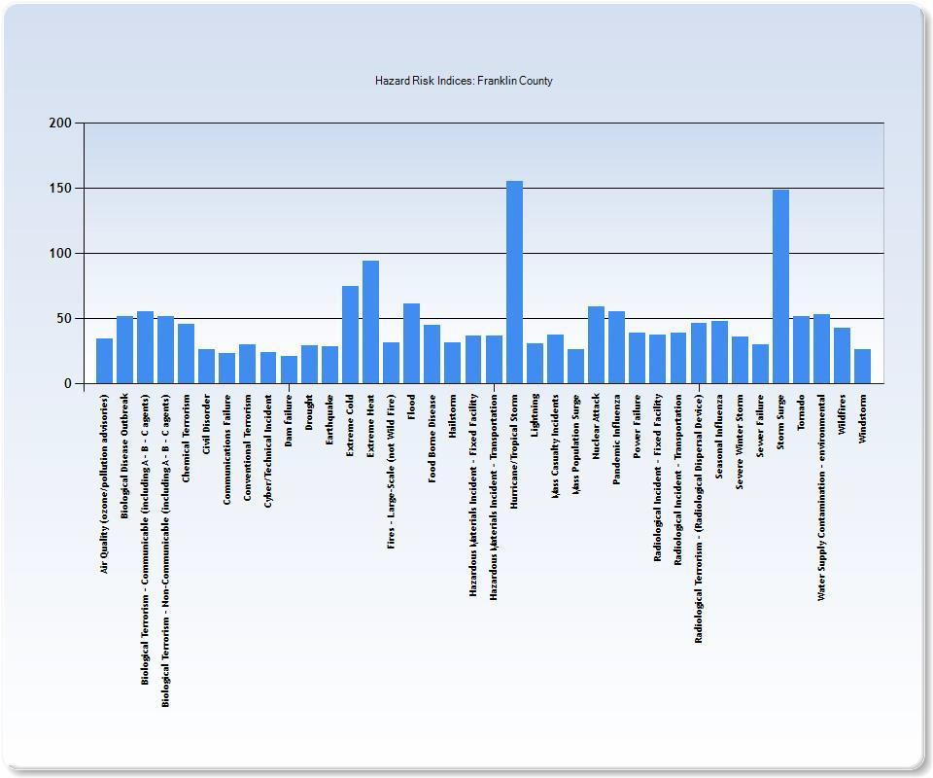
Franklin County Hazard Risk Indices Chart

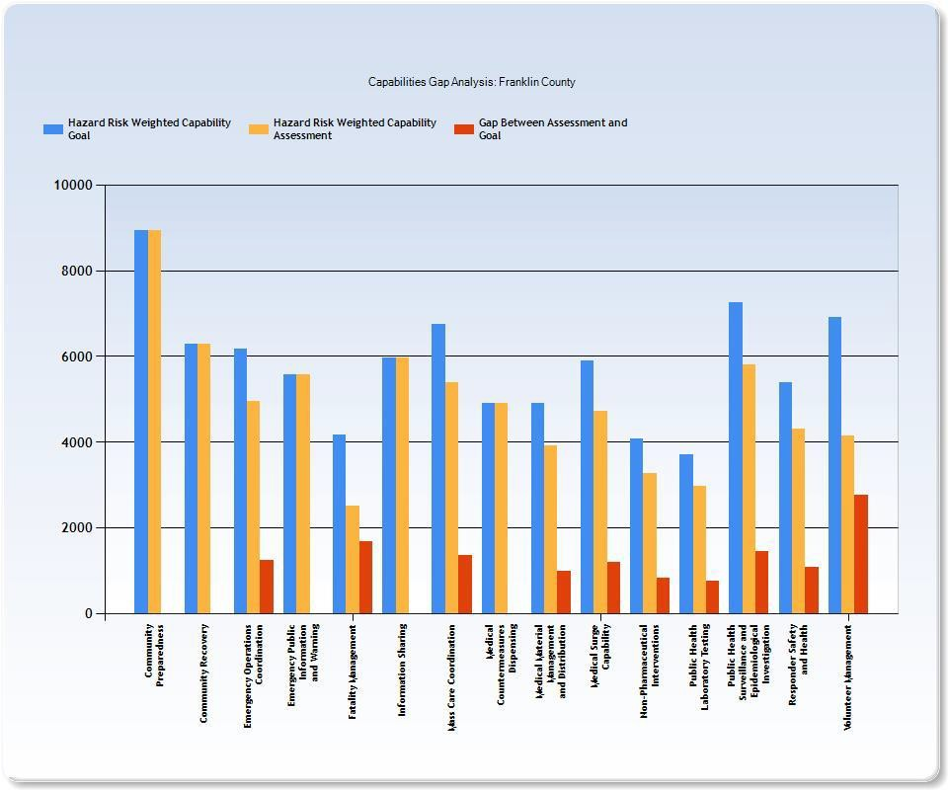
Franklin County Capabilities Gap Analysis

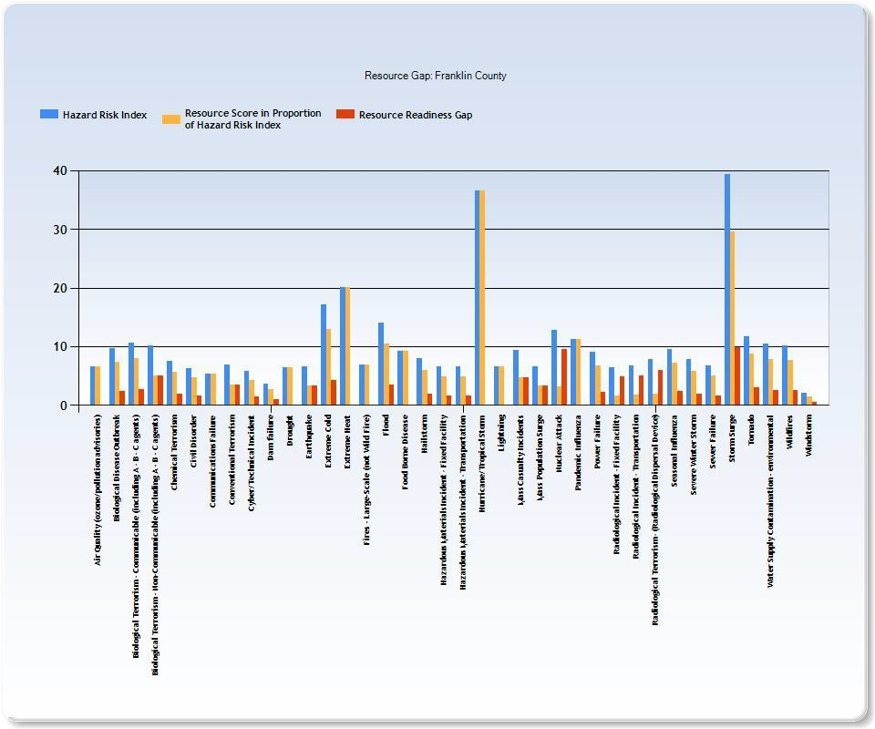
Franklin County Resource Gap

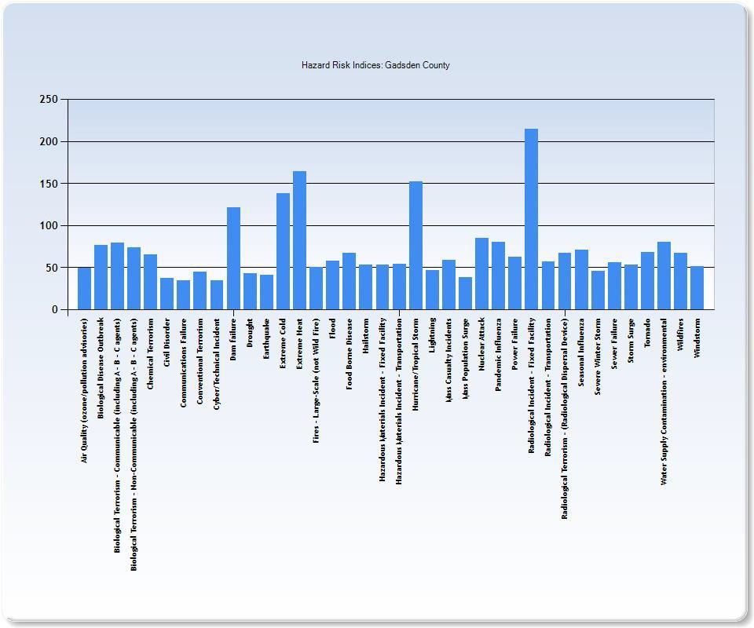
Gadsden County Hazard Risk Indices Chart

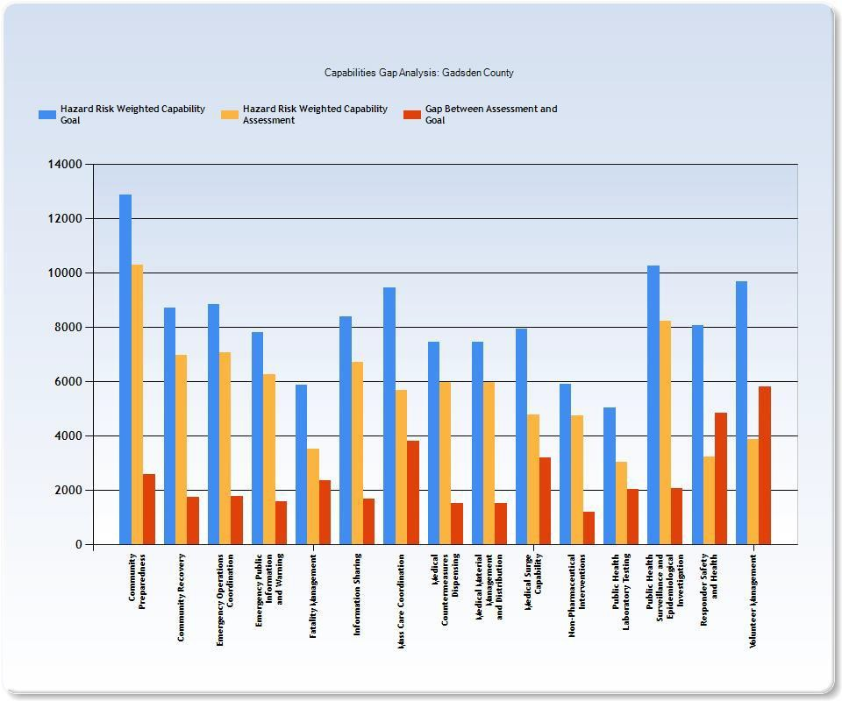
Gadsden County Capabilities Gap Analysis

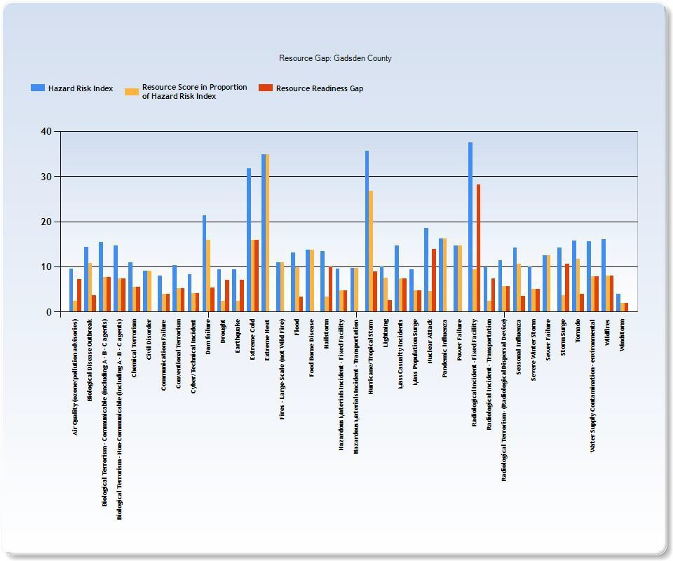
Gadsden County Resource Gap

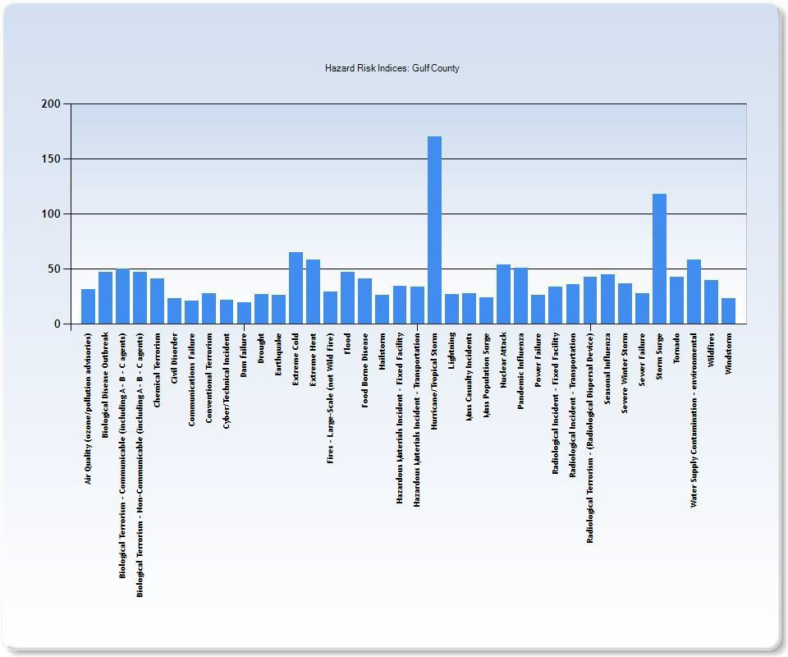
Gulf County Hazard Risk Indices Chart

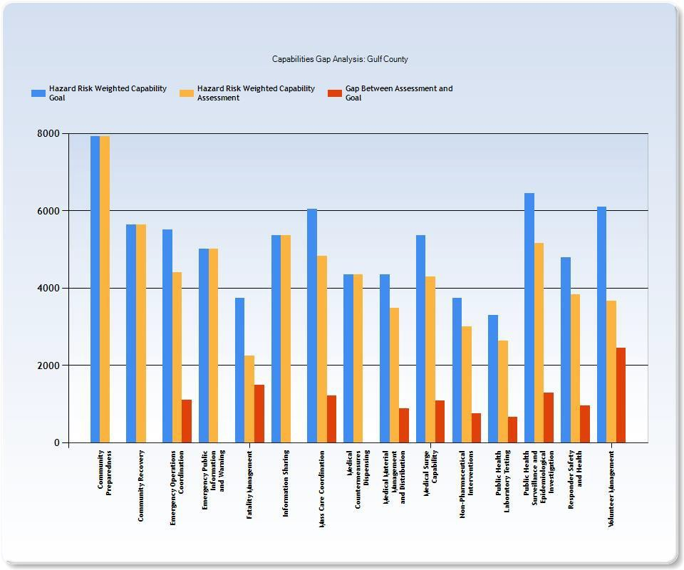
Gulf County Capabilities Gap Analysis

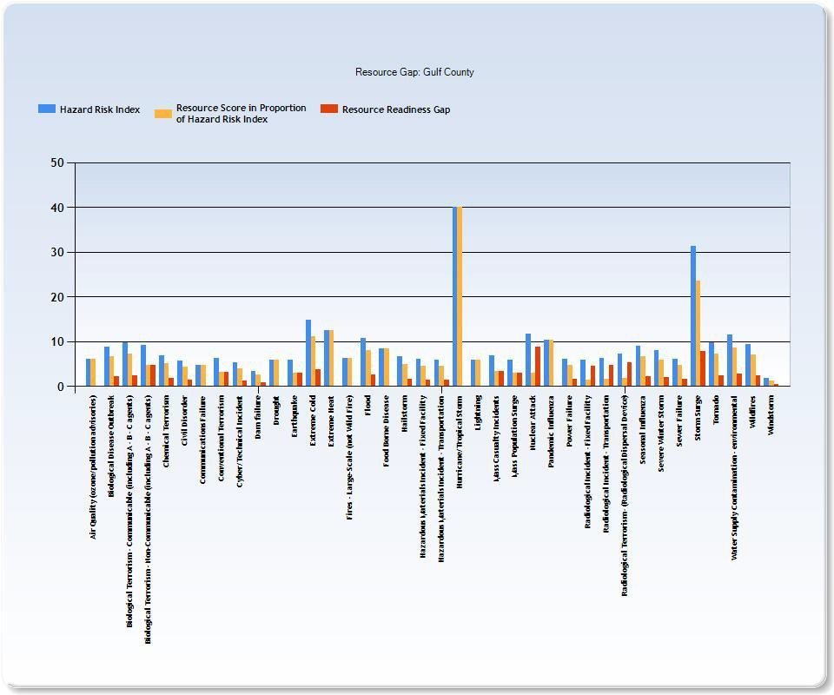
Gulf County Resource Gap

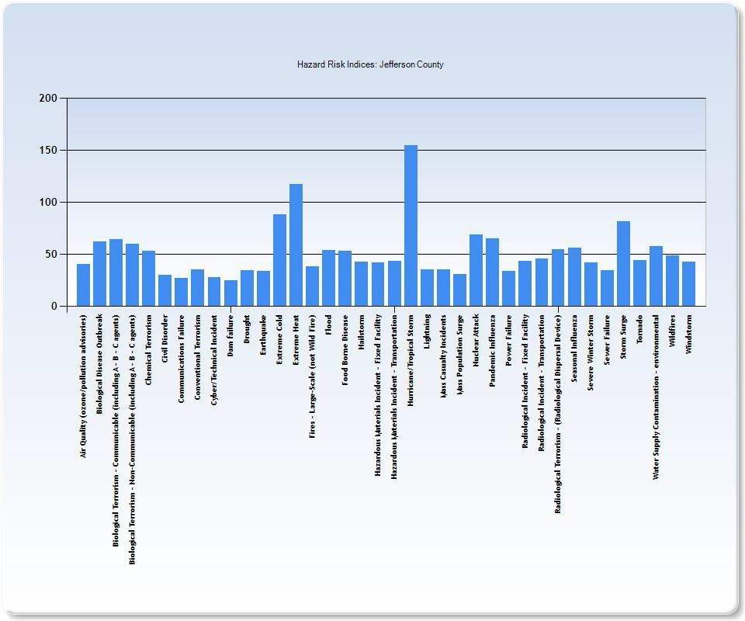
Jefferson County Hazard Risk Indices Chart

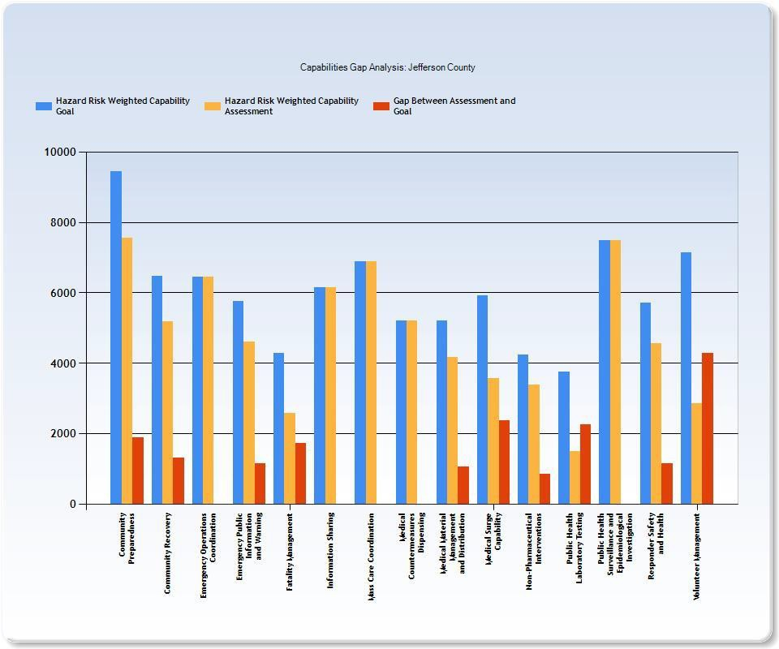
Jefferson County Capabilities Gap Analysis

0
0
...
..,
0
0
'-"
.,,.
0
I
Air Q.elity (ozone.tpolld:ion aduiloriM)
Biological Disease outbl"ealt Biolo,siCill Terrori1m- COIIIIDllcable (inch.ting A- B- C: i1genl:1) IIIIDIG91c11I Terroft1m- noo-commmilc11t>le(lncludnig A- D - c aigeds)
�a.
";;·'
"5'"
�
"'
chemlcEIII Terrorhm
ChlllDI, ,,.
(Qllllll�ll;:tUom r�lllff
i§
(iJ1111Cf'Clom1TrtTOri,m
� i;;
a.@
Cybot-tTod.-iiul lrKidod
Dilmfilil..-e
DrlJU!lhl
Eart""8ke
EKl.-eme cold
�::, ::,
�"2�-·
µ::, VJ
g:
j
::,
EKl.-emelletrl

Flff'I - l,arge-Sc1;llle {nOI Wld Fl.-e)
Flood
§
I
C
0
if
f'fllid 80mi:' OIU•Olif'
H;!ib1.onn
HH;:iinb,11, i- etcri;;i1,1ncldi:lll.. fbt,;,-dF{ldlHy
1
Hilzanloul: --.atmals: Incident • ltamportiltioo r===;a
H,Iriunetfiopiiul stmm
..
re
r
l
�""
CJ
::,
".'"
.'.
�"
"
ti
�
0
el
:,
Lisltni1111
l)ilHCEHIBlty lncldel1:!li
�""
b'
lyi:IH Popl.llation s..-ge
nuclear Attaidc pendenJlc l�Derqll Po.Met-hlhr�
R.aidlologlhcallndded - rboed reucUhy
Raiciolopjnl Torrori1m• (RadiolOSidl Di:.puniil DG'l.li�--E:=:s
SW:!iOllill ln'luonzil
�dill'.liugiol 1nc1d:."111. • 1ttne:ponirtlm
sevoceV!Ani:er-stonn

Se'l,/l,ll!I" Fail..-e

stonn5..-ge
Tom,oo
Wfler Sq>ply Cod11mlnatlon - envlronmedal
1'\11 ,.
W�otm
BBHCC - Hazard Vulnerability Analysis
Jefferson County Resource Gap
20

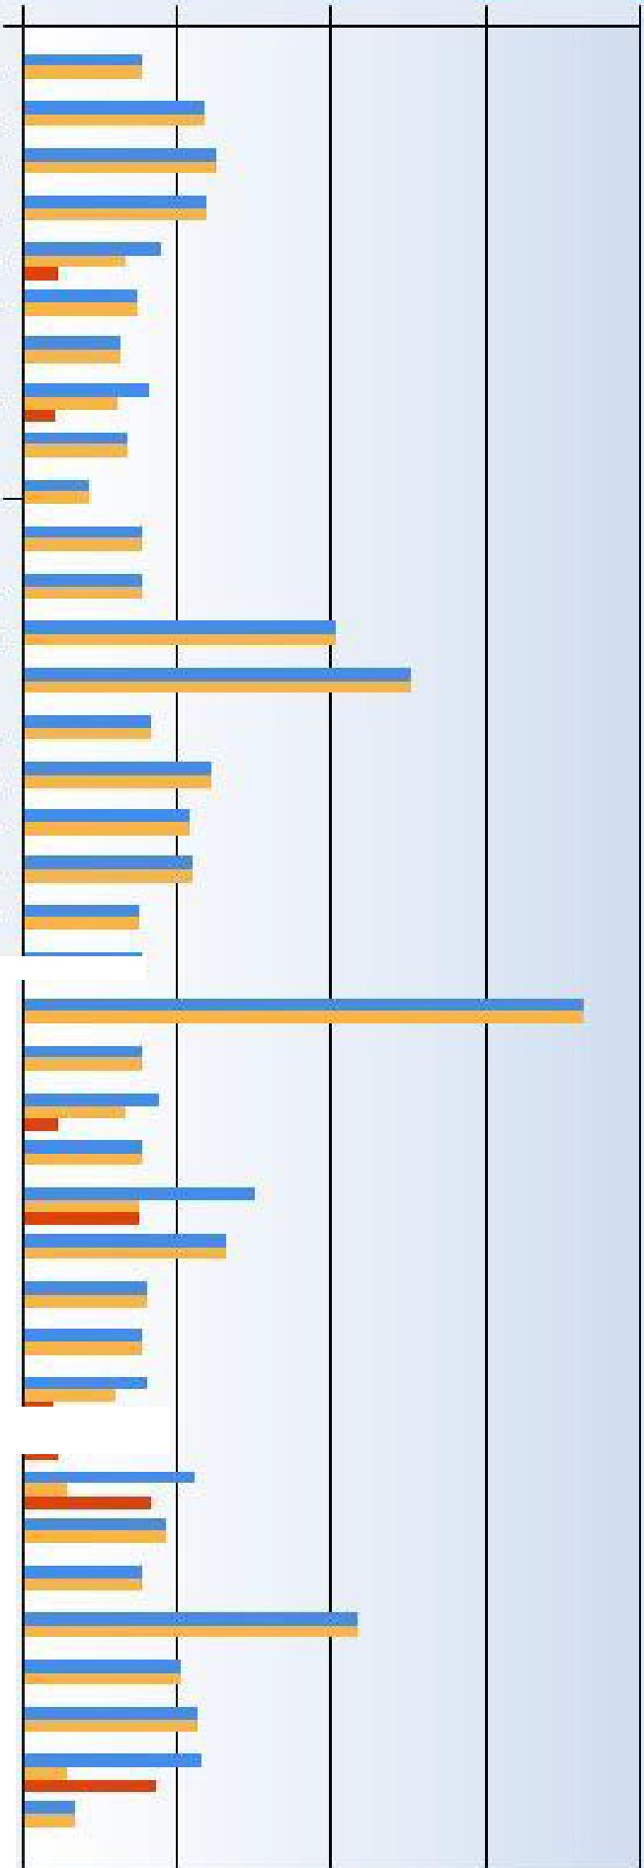

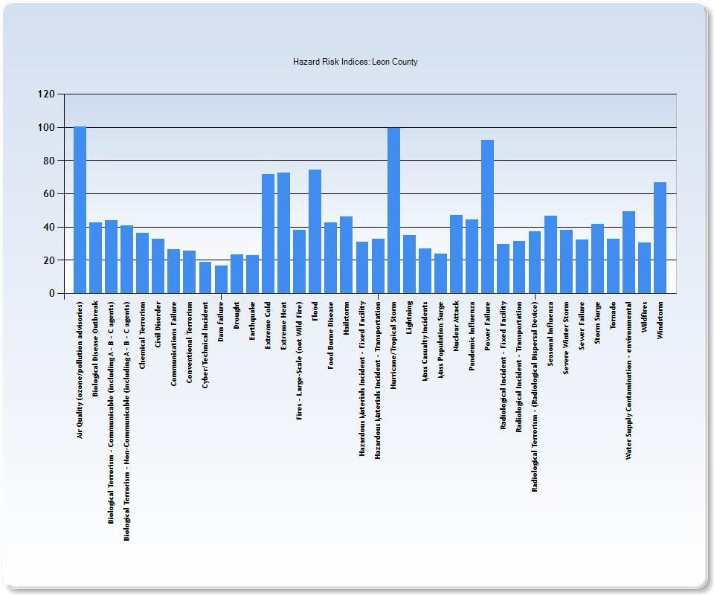
Leon County Hazard Risk Indices Chart

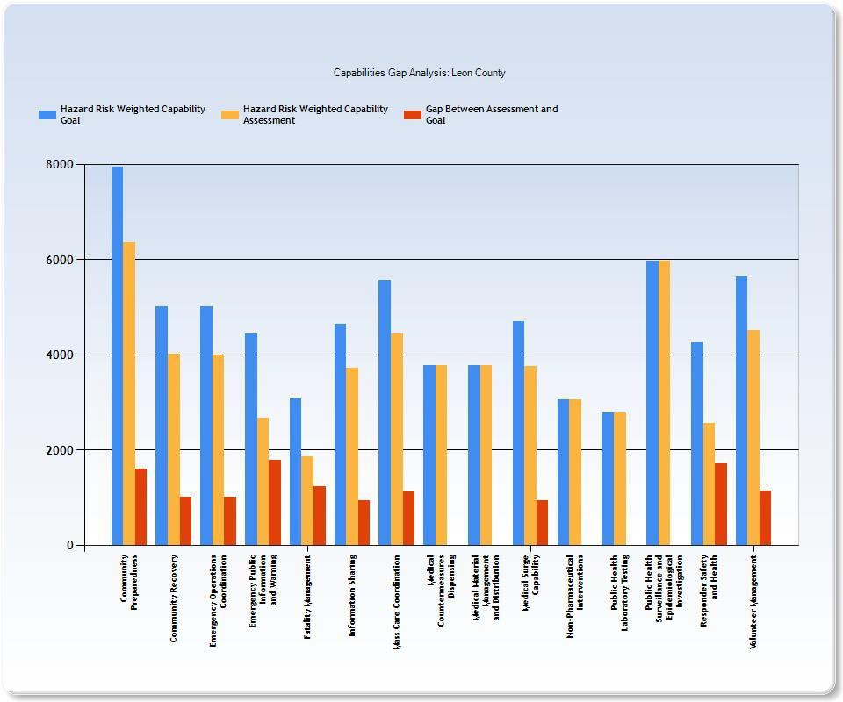
Leon County Capabilities Gap Analysis

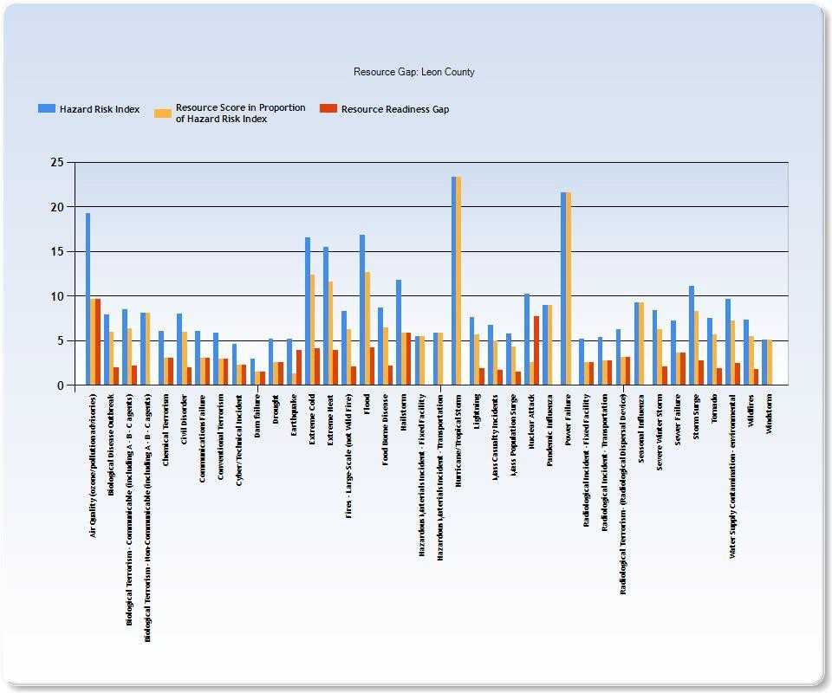
Leon County Resource Gap

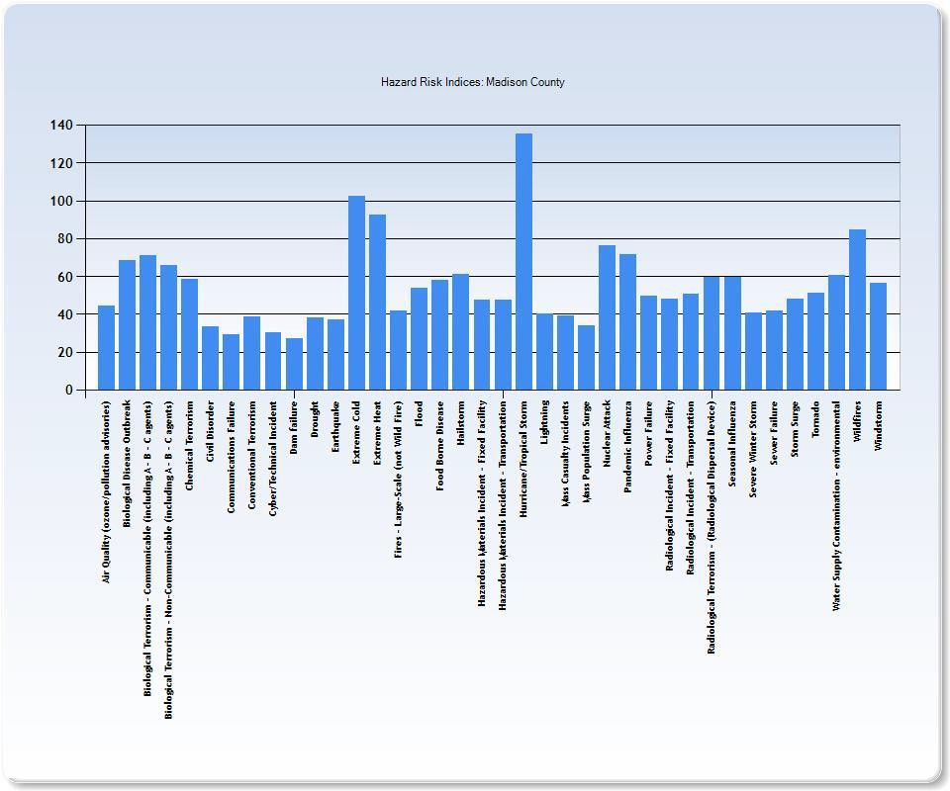
Madison County Hazard Risk Indices Chart

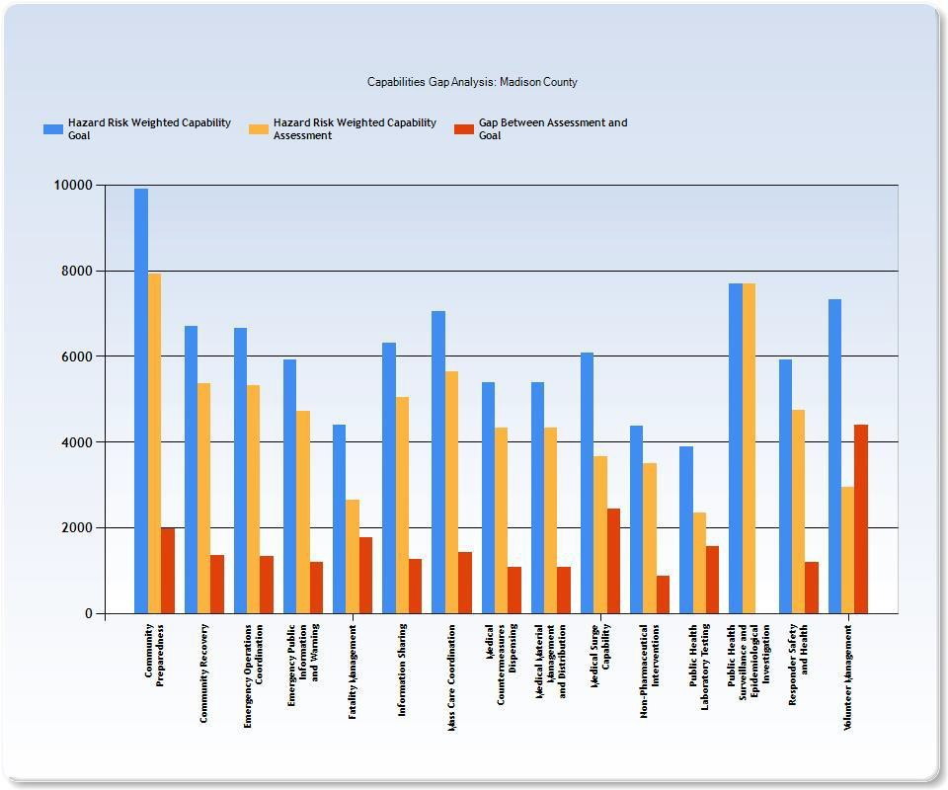
Madison County Capabilities Gap Analysis

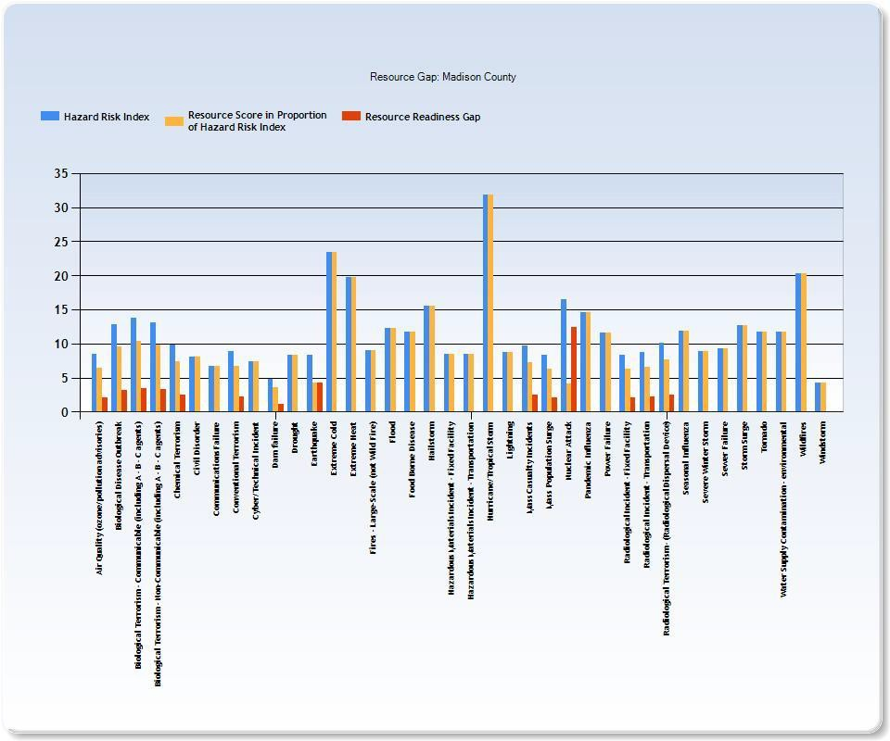
Madison County Resource Gap

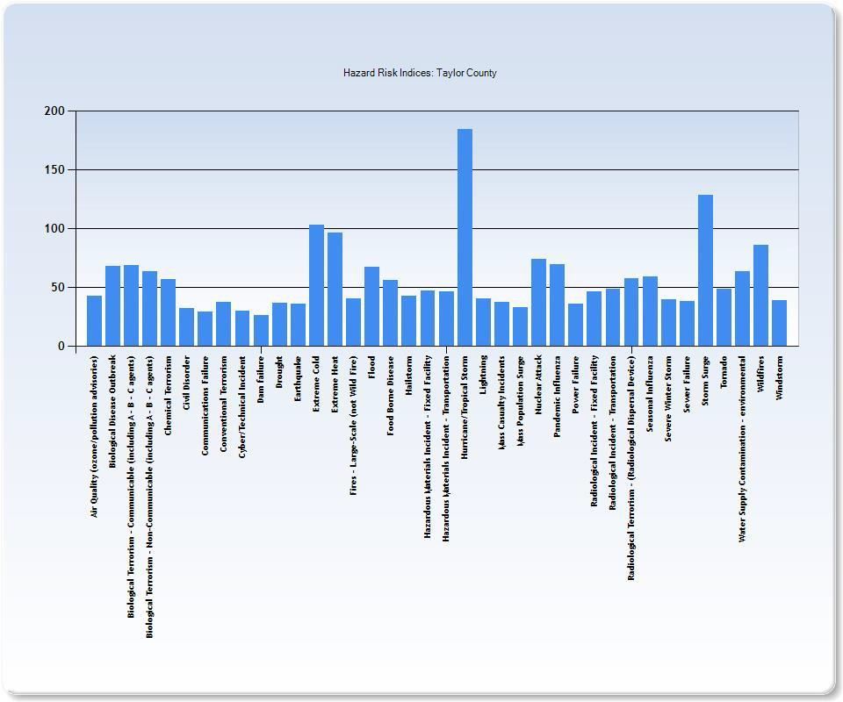
Taylor County Hazard Risk Indices Chart

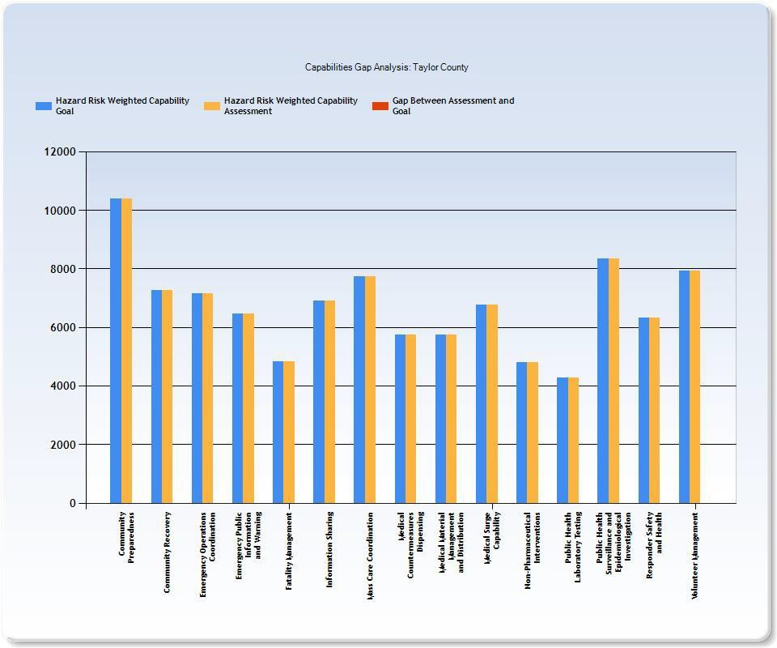
Taylor County Capabilities Gap Analysis

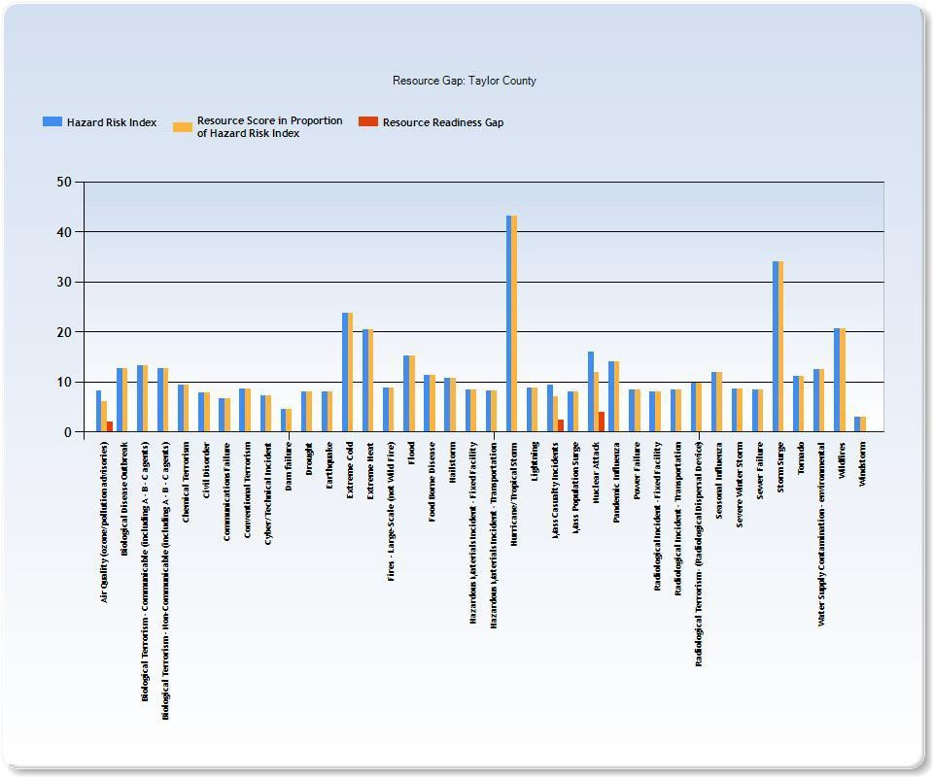
Taylor County Resource Gap

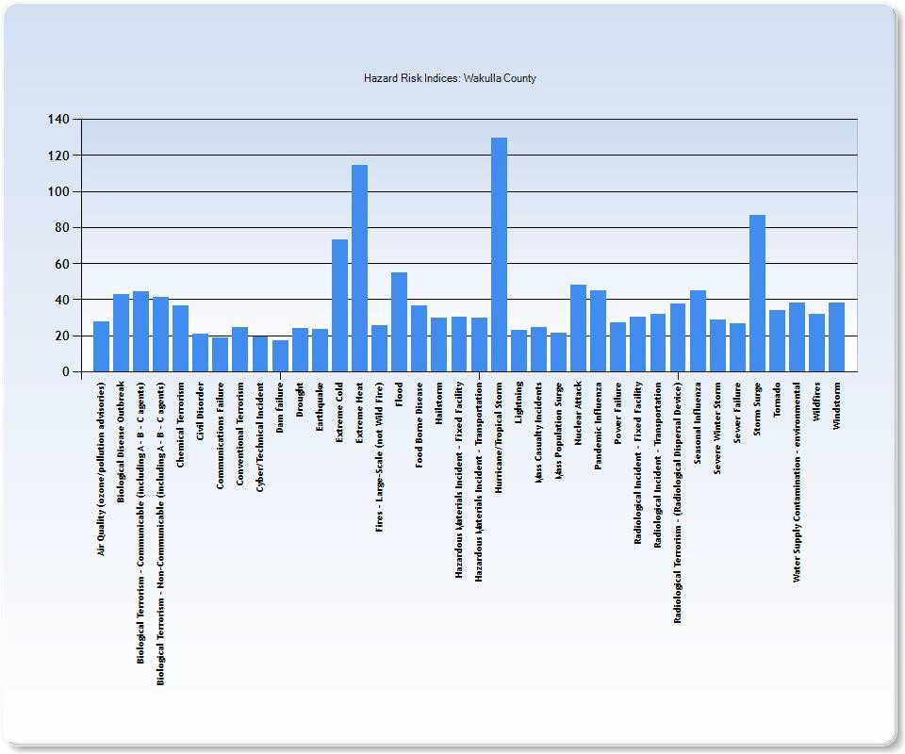
Wakulla County Hazard Risk Indices Chart

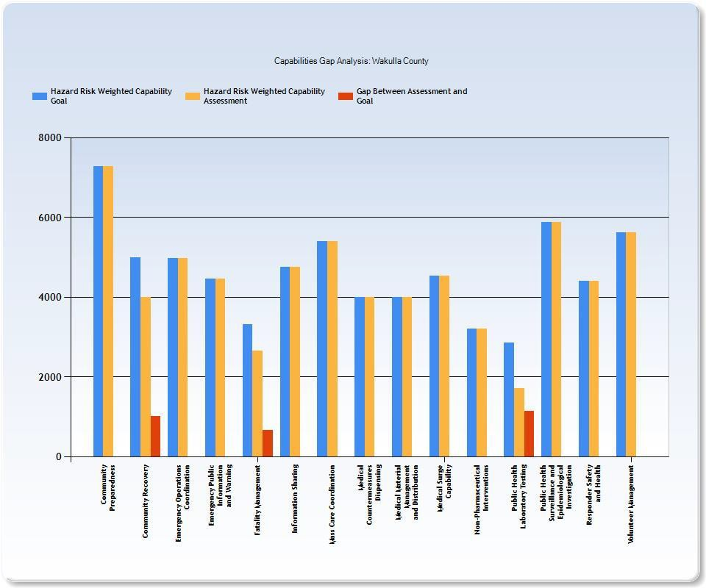
Wakulla County Capabilities Gap Analysis

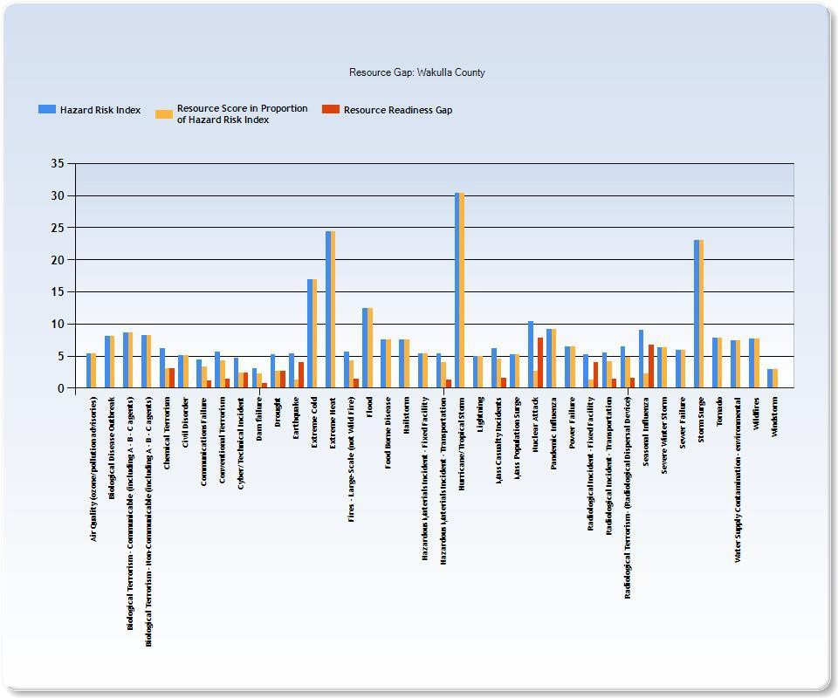
Wakulla County Resource Gap

Appendix B

Significant River Flood Outlook
Retrieved 12/09/2025
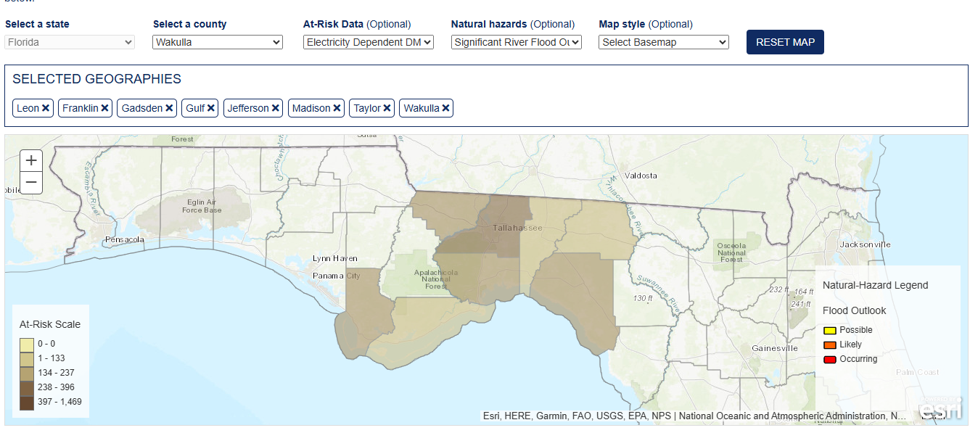

Geography | Beneficiaries | At-Risk Beneficiaries
Leon | 52774 | 1869
Franklin | 3409 | 160
Gadsden | 11069 | 443
Gulf | 4787 | 269
Jefferson | 4121 | 185
Madison | 5127 | 223
Taylor | 5184 | 262
Wakulla | 7990 | 348

Hazardous Weather-Watches & Warnings
Retrieved 12/09/2025

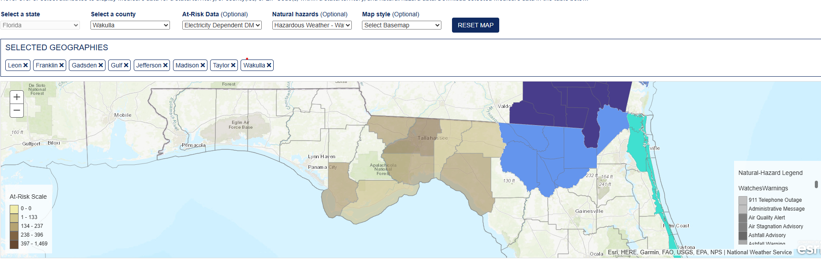

Geography | Beneficiaries | At-Risk Beneficiaries
Leon | 52774 | 1869
Franklin | 3409 | 160
Gadsden | 11069 | 443
Gulf | 4787 | 269
Jefferson | 4121 | 185
Madison | 5127 | 223
Taylor | 5184 | 262
Wakulla | 7990 | 348

Appendix C

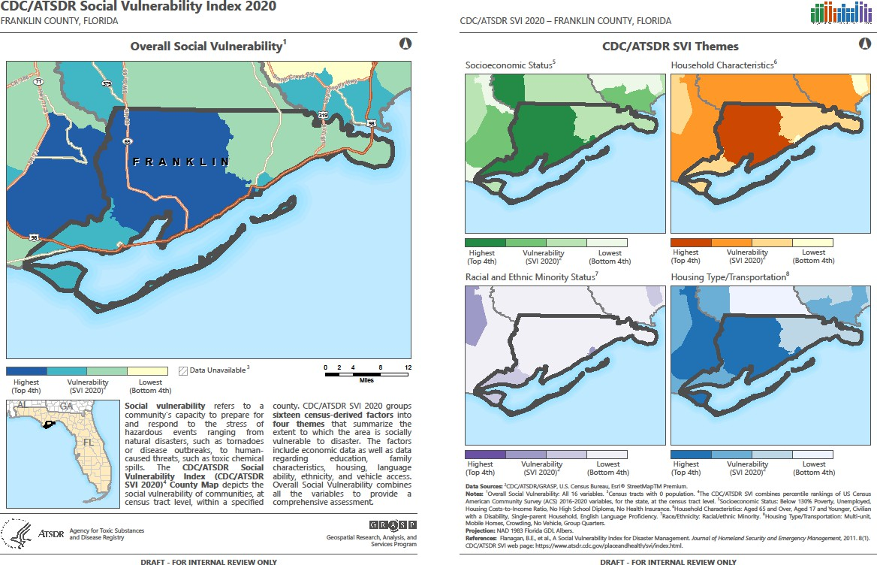
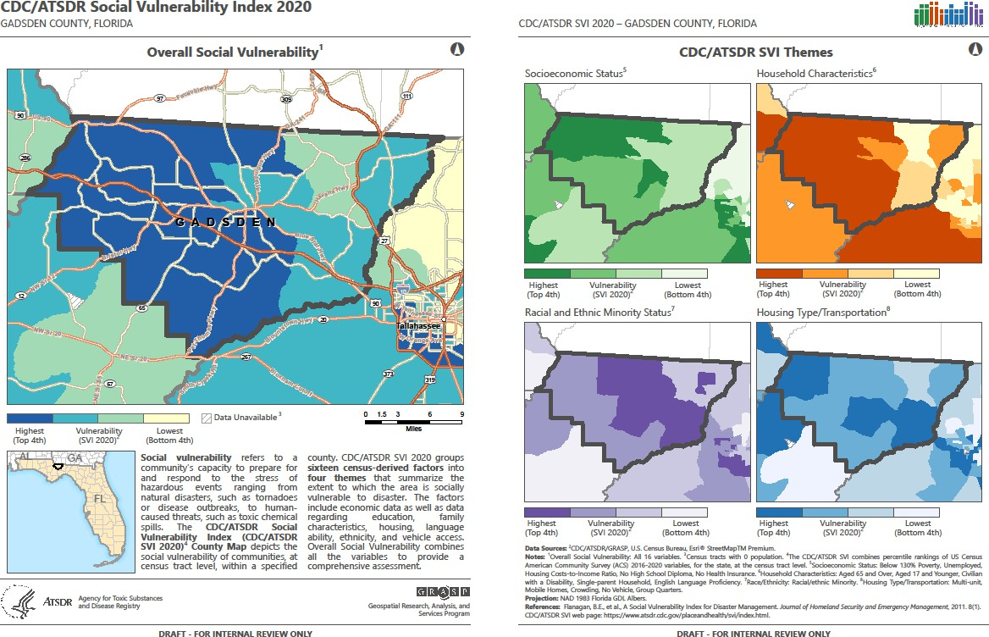

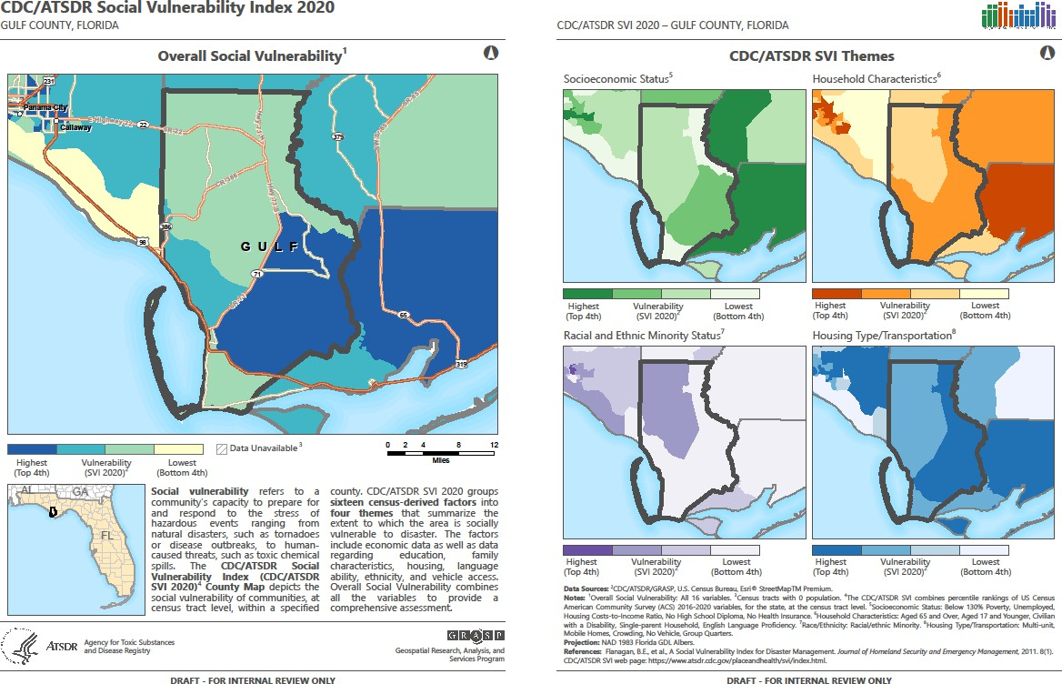

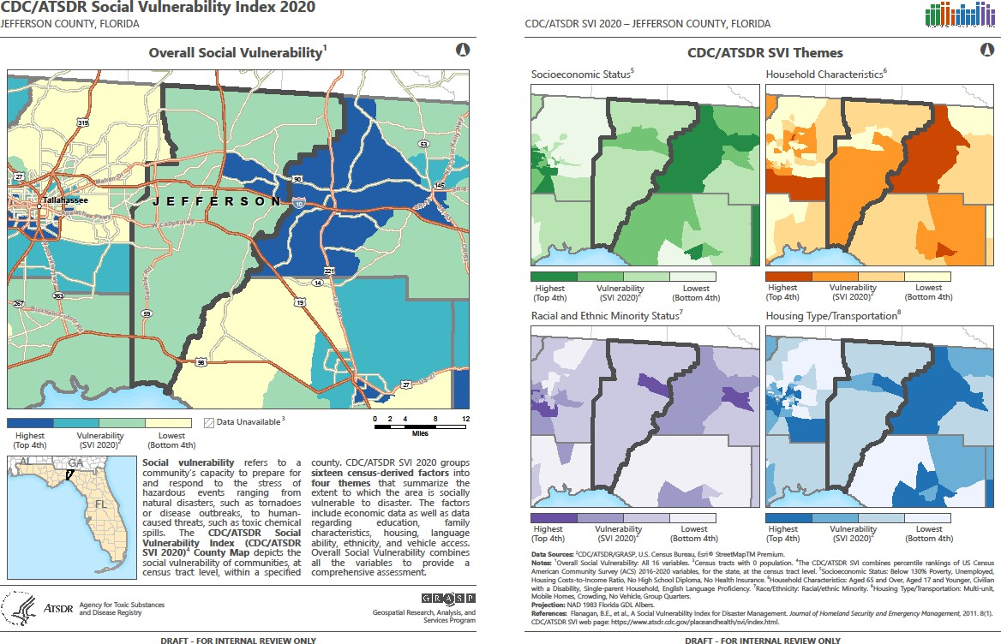

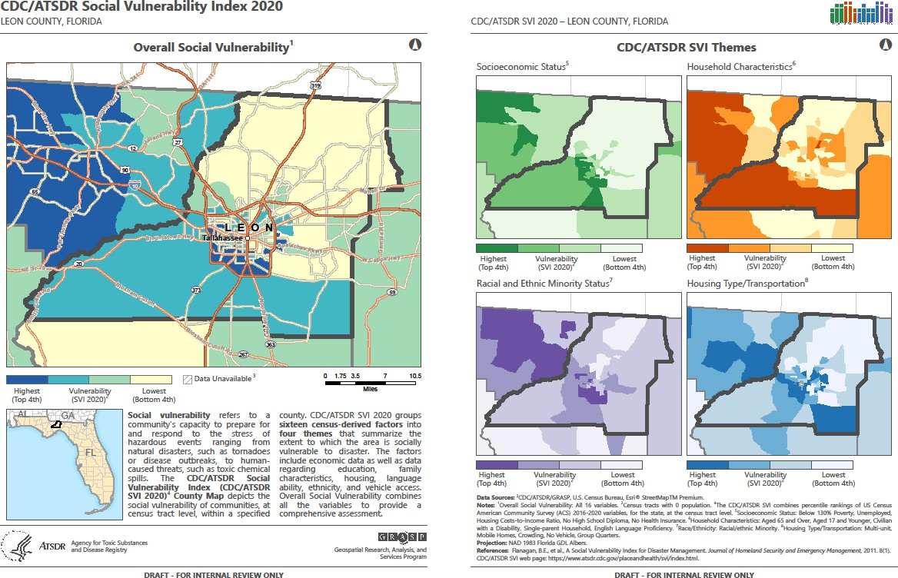
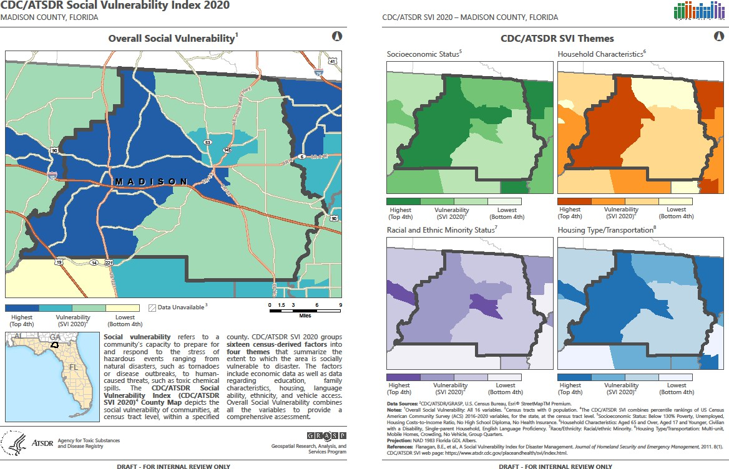

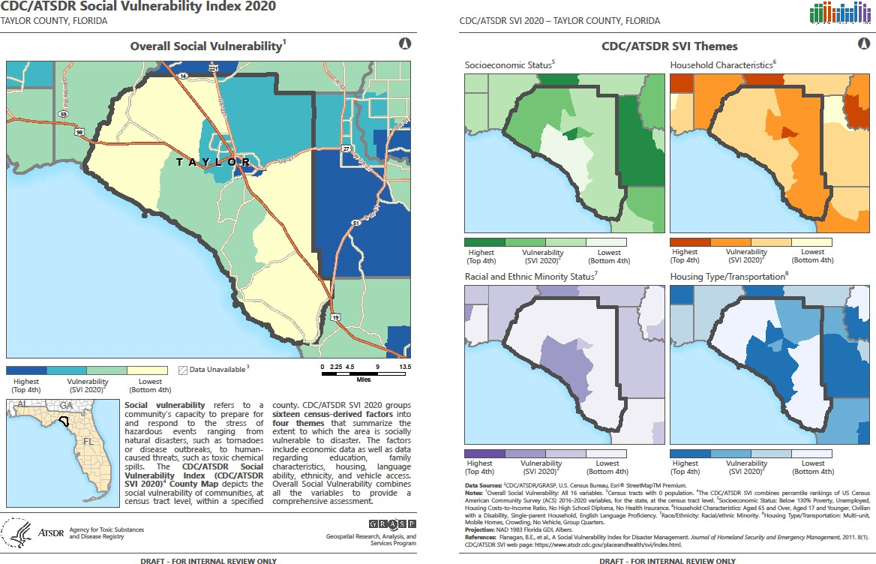

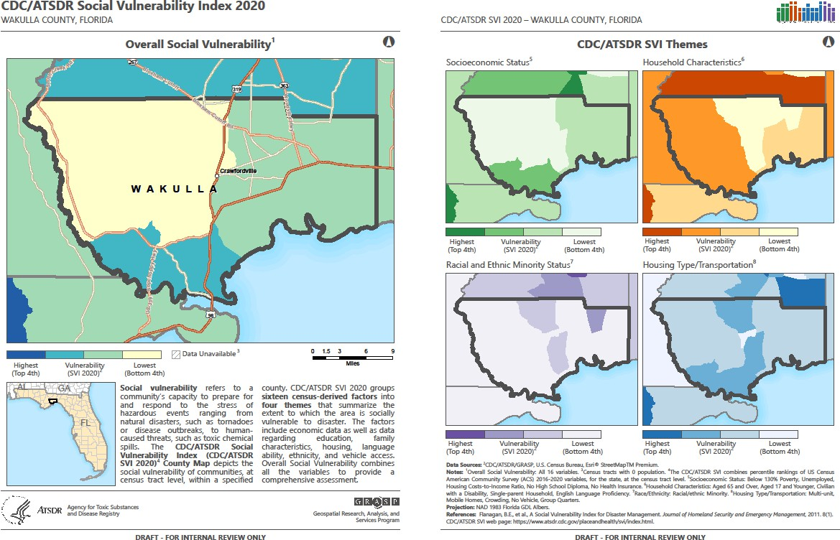

Appendix D- Member Participation

Participation List

Department/Facility Name
Florida Department of Health in Leon County
Monticello Nursing and Rehab
Southeastern Outpatient Surgery Center
City of Tallahassee Facilities Security
Tallahassee Memorial Home Health
Bond Community Health Center Inc.
BBAHEC
Gadsden county
Admin-MCMH
Gulf County Department of Health
DOH-Wakulla
Gadsden County
DOH-Franklin
Leon County EMS

